AUTHORSHIP STATEMENT

Manuscript title: Effect of Different Feeding Rates on the Growth of Osphronemus goramy: Corncob Flour as Complementary
___________________________________________________________________________

I, the undersigned and on behalf of all the authors listed below declared that all authors have contributed, read, and approved the written research work described in this manuscript to be submitted to the Jurnal Riset Akuakultur. We also acknowledge that the copyright of this article will be transferred to the journal once accepted for publication.
We confirm the role of each author (YY, FF, and SR) as the following based on CRedit taxonomy (https://credit.niso.org/):
YY: Conceptualization, Data curation, Formal Analysis, Funding acquisition, Investigation, Methodology, Project administration, Resources, Software, Supervision, Validation, Visualization, Writing – original draft, Writing – review & editing; FF: Formal Analysis, Funding acquisition, Project administration, Supervision, Validation, Visualization, Writing – original draft, Writing – review & editing; SR: Supervision, Visualization, Writing – original draft, Writing – review & editing.

Full Name of Author | Role (Corresponding/Co-Author)
Yulfiperius Yulfiperius | Corresponding Author & Co-Author
Firman Firman | Co-Author
Sri Hartini | Co-Author

Sincerely,
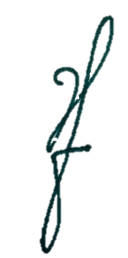
First/Corresponding Author

[Yulfiperius]

