**AUTHORSHIP STATEMENT**

Manuscript title :

EFFECTS OF FEEDING RATE REDUCTION ON THE GROWTH PERFORMANCE AND FEED UTILIZATION OF PACIFIC WHITE SHRIMP REARED USING BIOFLOC SYSTEM ______________________________________________________________________________

I, the undersigned and on behalf of all the authors listed below declared that all authors have contributed, read and approve the written research work described in this manuscript to be submitted to the Jurnal Riset Akuakultur. We also acknowledge that the copyright of this article will be transferred to the journal once accepted for publication.

We confirm that the role of each author (abbreaviate name) as the following based on CRedit taxonomy (https://credit.niso.org/):

AK: Conceptualization, Data curation, Formal Analysis, Funding acquisition, Investigation, Methodology, Project administration, Resources, Supervision, Validation, Visualization, Writing – original draft, Writing – review and editing; DASU: Conceptualization, Data curation, Formal Analysis, Investigation, Methodology, Resources, Software, Validation, Visualization, Writing – original draft, Writing – review and editing; TH: Conceptualization, Methodology; ST: Conceptualization, Methodology; MST: Conceptualization, Methodology; TF: Project administration, Investigation, Resources; YEK: Project administration, Investigation, Resources; RD: Conceptualization, Methodology; UT: Conceptualization, Methodology; MAS: Project administration, Investigation, Resources.

|  |  |
| --- | --- |
| Full Name of Author | Role (Corresponding/Co-Author) |
| Anik Kusmiatun (AK) | First Author and Corresponding Author |
| Diah Ayu Satyari Utami (DASU) | Co-Author |
| Teguh Harijono (TH) | Co-Author |
| Sartika Tangguda (ST) | Co-Author |
| Meilya Suzan Triyastuti (MST) | Co-Author |
| Tata Firnaeni (TF) | Co-Author |
| Yasinta Ega Kaborang (YEK) | Co-Author |
| Ricky Djauhari (RD) | Co-Author |
| Uras Tantulo (UT) | Co-Author |
| Mika A. Sihombing (MAS) | Co-Author |

Sincerely,

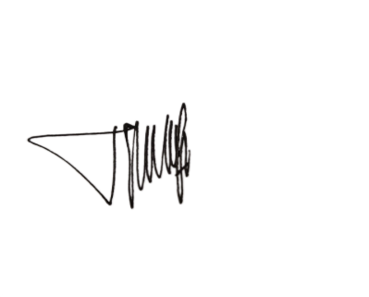First Author/Corresponding Author

Anik Kusmiatun