**AUTHORSHIP STATEMENT**

Manuscript title :

Correlation Between Microplastic Abundance and Histopathological Damage in Gills and Intestines of Whiteleg Shrimp (Litopenaeus vannamei) In Probolinggo, East Java

I, the undersigned and on behalf of all the authors listed below declared that all authors have contributed, read and approve the written research work described in this manuscript to be submitted to the Jurnal Riset Akuakultur. We also acknowledge that the copyright of this article will be transferred to the journal once accepted for publication.

We confirm that the role of each author (abbreaviate name) as the following based on CRedit taxonomy (https://credit.niso.org/):

**AFRP:** Conceptualization, Methodology, Investigation, Formal analysis, Writing – original draft, Visualization; **AMSH**: Supervision, Validation, Writing – review & editing; YM**:** Supervision, Validation, Writing – review & editing

|  |  |
| --- | --- |
| Full Name of Author | Role (Corresponding/Co-Author) |
| Andhika Farras Rahardian Putra | Corresponding Author |
| Asus Maizar Suryanto Hertika | Co-Author |
| Yunita Maimunah | Co-Author |

Sincerely,

First/Corresponding Author

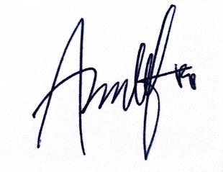

Andhika Farras Rahardian Putra