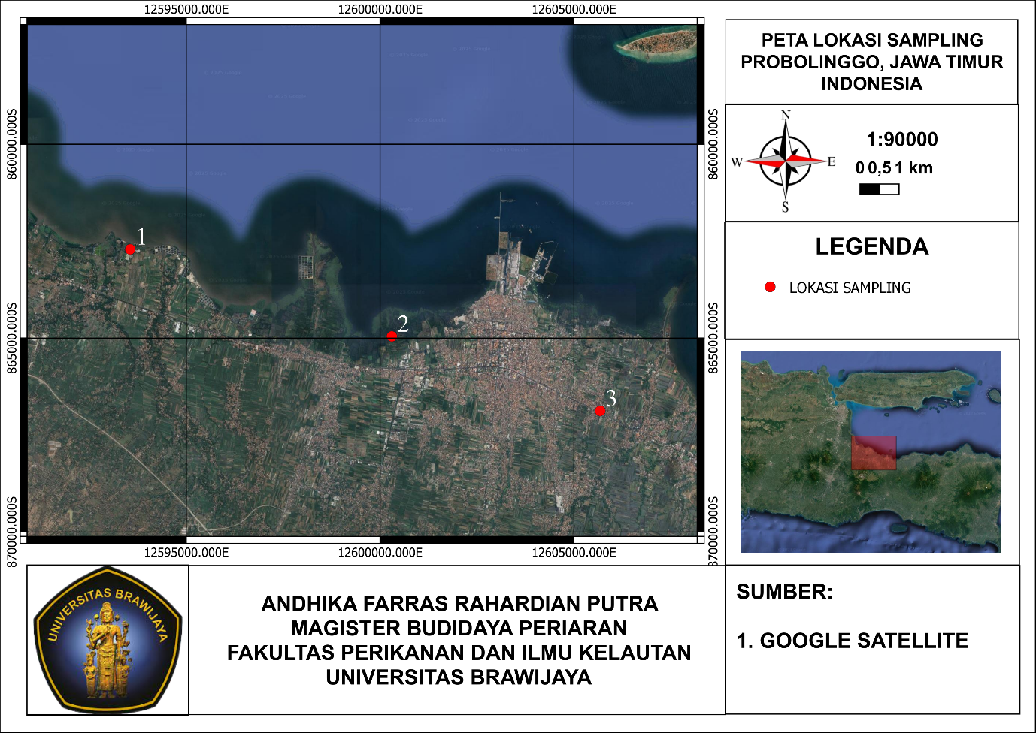

Gambar 1. Lokasi Pengambilan Sampel Penelitian

Figure 1. Research Sampling Location

Tabel 1. Interpretasi Nilai r Korelasi Spearman

*Table 1. Interpretation of Spearman Correlation r Value*

|  |  |
| --- | --- |
| Nilai r | Interpretasi |
| 0,00-1,199 | Sangat rendah |
| 0,20-0,399 | Rendah |
| 0,40-0,599 | Sedang |
| 0,60-0,799 | Kuat |
| 0,800-1,000 | Sangat kuat |

Tabel 2. Kelimpahan Mikroplastik pada Organ Insang dan Usus Udang Vannamei

Table 2. Abundance of Microplastics in the Gills and Intestines of Vannamei Shrimp

|  |  |  |  |
| --- | --- | --- | --- |
| **Lokasi** | **Sampling** | **Kelimpahan Mikroplastik (Partikel/gr)** | |
| **Insang** | **Usus** |
| Tambak 1 | 1 | 77.05 | 1736.43 |
| 2 | 86.35 | 1987.95 |
| 3 | 93.88 | 2075.42 |
| Tambak 2 | 1 | 71.43 | 1359.29 |
| 2 | 85.24 | 1711.06 |
| 3 | 85.81 | 1834.67 |
| Tambak 3 | 1 | 55.56 | 1497.84 |
| 2 | 83.51 | 1558.65 |
| 3 | 91.27 | 1931.08 |

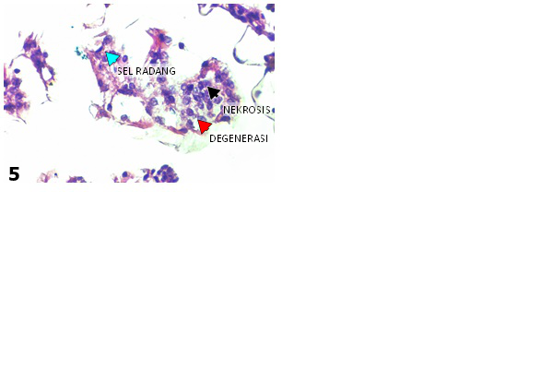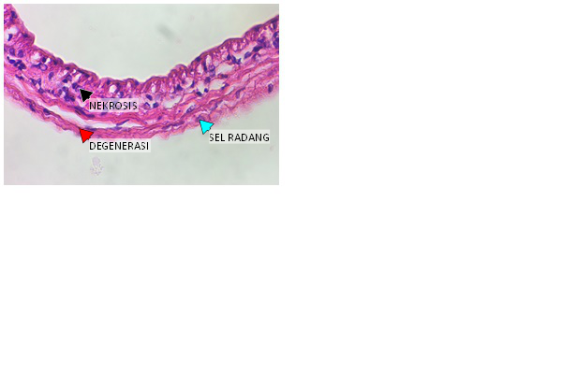

b)

a)

Gambar 2. a) Histopatologi Kerusakan Organ Insang, b) Histopatologi Kerusakan Organ usus

Figure 2. a) Histopathology of Gill Organ Damage, b) Histopathology of Intestinal Organ Damage

Tabel 3. Tingkat Kerusakan Organ pada Insang dan Usus Udang Vannamei

Table 3. Level of Organ Damage to Gills and Intestines of Vannamei Shrimp

|  |  |  |  |  |  |
| --- | --- | --- | --- | --- | --- |
| **Tambak** | **Sampling** | **Skor Insang** | **Degenerasi** | **Nekrosis** | **Inflamasi** |
| 1 | 1 | 1 | 1.6 | 1 | 1.4 |
| 2 | 1.8 | 2.2 | 2.2 | 1.4 |
| 3 | 1.4 | 3 | 2.6 | 2.6 |
| 2 | 1 | 0.8 | 1.6 | 1.4 | 1.4 |
| 2 | 1.4 | 1.8 | 1.6 | 1.6 |
| 3 | 2.8 | 2.2 | 2.2 | 1.8 |
| 3 | 1 | 0.8 | 1.2 | 1.4 | 1 |
| 2 | 1.2 | 1.4 | 1.6 | 1.4 |
| 3 | 2.2 | 2.2 | 2.2 | 2.2 |