Lampiran 1. Komponen dan Profil Reaksi PCR

Komposisi Reaksi PCR

|  |  |
| --- | --- |
| Komponen | Volume (50 μL Reaksi) |
| My Taq HS Red Mix | 25 μL |
| Primer *Forward* (20 μM) | 1 μL |
| Primer *Reverse* (20 μM) | 1 μL |
| DNA cetakan (200 ng) | 1 μL |
| Deion (ddH2O) | Hingga 50 μL |

**Profil PCR**

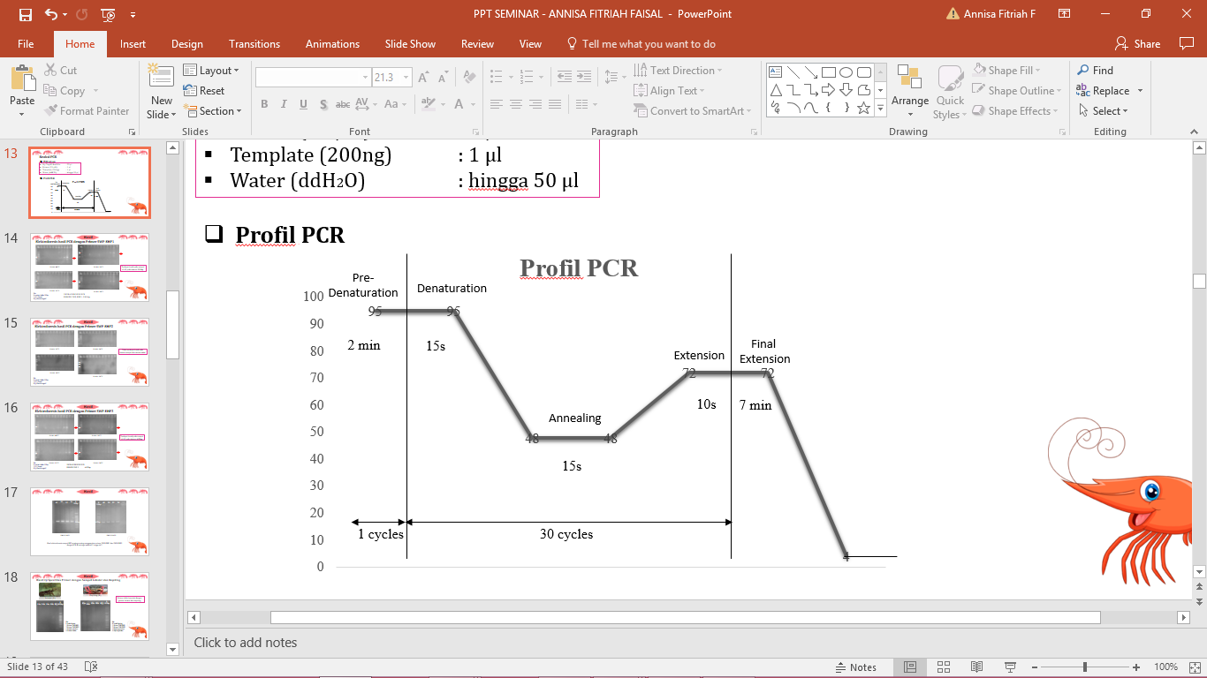

**Lampiran 2. Rumus Bilangan Avogadro**

Jumlah kopi DNA = $\frac{(Jumlah DNA (ng) * 6.022 x {10}^{23}) }{(Panjang \left(bp\right) *1 x {10}^{9}* 650)}$

Keterangan:

- Jumlah DNA = Jumlah DNA (Plasmid, primer, dll) dalam satuan nanogram

- 6.022 x 1023 = Bilangan Avogadro (molekul/mol)

- Panjang = Panjang fragmen DNA dalam pasang basa.

- 1 x 109 = Bilangan untuk konversi jawaban ke nanogram

- 650 g/mol = Berat rata-rata pasangan basa tunggal DNA (bp)

Lampiran 3. Hasil BLAST Primer SWP-EHP1 dan Primer SWP-EHP3

Hasil BLAST Primer SWP-EHP1 *Forward*

|  |  |  |  |  |  |  |
| --- | --- | --- | --- | --- | --- | --- |
| **Deskripsi** | **Skor maks** | **Skor total** | ***Query cover*** | ***E value*** | ***Identity*** | **No. Akses** |
| *Enterocytozoon hepatopenaei spore wall protein 1 (SWP1) mRNA, complete cds* | 42.1 | 42.1 | 100% | 0.075 | 100% | MG015710.1 |
| *Enterocytozoon hepatopenaei spore wall protein gene, partial cds* | 42.1 | 42.1 | 100% | 0.075 | 100% | KY593132.2 |
| *Enterocytozoon hepatopenaei spore wall protein 1 gene, partial cds* | 42.1 | 42.1 | 100% | 0.075 | 100% | KY674357.1 |
| *Enterocytozoon hepatopenaei spore wall protein gene, partial cds* | 42.1 | 42.1 | 100% | 0.075 | 100% | KY593133.1 |
| *Enterocytozoon hepatopenaei isolate EHP1SWP spore wall protein 1 gene, partial cds* | 42.1 | 42.1 | 100% | 0.075 | 100% | KY483639.1 |
| *Enterocytozoon hepatopenaei spore wall protein 1 (SWP) gene, partial cds* | 42.1 | 42.1 | 100% | 0.075 | 100% | KX258197.1 |
| *Enterocytozoon hepatopenaei spore wall protein gene, partial cds* | 42.1 | 42.1 | 100% | 0.075 | 100% | KY593129.1 |

Hasil BLAST Primer SWP-EHP1 *Reverse*

|  |  |  |  |  |  |  |
| --- | --- | --- | --- | --- | --- | --- |
| **Deskripsi** | **Skor maks** | **Skor total** | ***Query cover*** | ***E value*** | ***Identity*** | **No. Akses** |
| *Enterocytozoon hepatopenaei spore wall protein 1 (SWP1) mRNA, complete cds* | 44.1 | 44.1 | 100% | 0.019 | 100% | MG015710.1 |
| *Enterocytozoon hepatopenaei spore wall protein gene, partial cds* | 44.1 | 44.1 | 100% | 0.019 | 100% | KY593132.2 |
| *Enterocytozoon hepatopenaei spore wall protein 1 gene, partial cds* | 44.1 | 44.1 | 100% | 0.019 | 100% | KY674357.1 |
| *Enterocytozoon hepatopenaei spore wall protein gene, partial cds* | 44.1 | 44.1 | 100% | 0.019 | 100% | KY593133.1 |
| *Enterocytozoon hepatopenaei spore wall protein gene, partial cds* | 44.1 | 44.1 | 100% | 0.019 | 100% | KY593129.1 |
| *Enterocytozoon hepatopenaei isolate EHP1SWP spore wall protein 1 gene, partial cds* | 44.1 | 44.1 | 100% | 0.019 | 100% | KY483639.1 |
| *Enterocytozoon hepatopenaei spore wall protein 1 (SWP) gene, partial cds* | 44.1 | 44.1 | 100% | 0.019 | 100% | KX258197.1 |

Hasil BLAST Primer SWP-EHP3 *Forward*

|  |  |  |  |  |  |  |
| --- | --- | --- | --- | --- | --- | --- |
| **Deskripsi** | **Skor maks** | **Skor total** | ***Query cover*** | ***E value*** | ***Identity*** | **No. Akses** |
| *Enterocytozoon hepatopenaei spore wall protein 1 (SWP1) mRNA, complete cds* | 44.1 | 44.1 | 100% | 0.019 | 100% | MG015710.1 |
| *Enterocytozoon hepatopenaei spore wall protein gene, partial cds* | 44.1 | 44.1 | 100% | 0.019 | 100% | KY593132.2 |
| *Enterocytozoon hepatopenaei spore wall protein 1 gene, partial cds* | 44.1 | 44.1 | 100% | 0.019 | 100% | KY674357.1 |
| *Enterocytozoon hepatopenaei spore wall protein gene, partial cds* | 44.1 | 44.1 | 100% | 0.019 | 100% | KY593133.1 |
| *Enterocytozoon hepatopenaei spore wall protein gene, partial cds* | 44.1 | 44.1 | 100% | 0.019 | 100% | KY593129.1 |
| *Enterocytozoon hepatopenaei isolate EHP1SWP spore wall protein 1 gene, partial cds* | 44.1 | 44.1 | 100% | 0.019 | 100% | KY483639.1 |
| *Enterocytozoon hepatopenaei spore wall protein 1 (SWP) gene, partial cds* | 44.1 | 44.1 | 100% | 0.019 | 100% | KX258197.1 |

Hasil BLAST Primer SWP-EHP3 *Reverse*

|  |  |  |  |  |  |  |
| --- | --- | --- | --- | --- | --- | --- |
| **Deskripsi** | **Skor maks** | **Skor total** | ***Query cover*** | ***E value*** | ***Identity*** | **No. Akses** |
| *Enterocytozoon hepatopenaei spore wall protein 1 (SWP1) mRNA, complete cds* | 46.1 | 46.1 | 100% | 0.007 | 100% | MG015710.1 |
| *Enterocytozoon hepatopenaei spore wall protein gene, partial cds* | 46.1 | 46.1 | 100% | 0.007 | 100% | KY593132.2 |
| *Enterocytozoon hepatopenaei spore wall protein 1 gene, partial cds* | 46.1 | 46.1 | 100% | 0.007 | 100% | KY674357.1 |
| *Enterocytozoon hepatopenaei spore wall protein gene, partial cds* | 46.1 | 46.1 | 100% | 0.007 | 100% | KY593133.1 |
| *Enterocytozoon hepatopenaei spore wall protein 1 (SWP) gene, partial cds* | 46.1 | 46.1 | 100% | 0.007 | 100% | KX258197.1 |

Lampiran 4. Pensejajaran Sekuen Asam Amino pGEM-HP1 dan pGEM-HP3 dengan SWP EHP Kode Lainnya



**Sekuen Asam Amino pGEMHP1 dan pGEMHP3**

>SWP_EHP_pGEMHP1

HWSNTISNTVNLKALKRDDIYTDTAFVGYELSNTVGDKQLKEVCNDFSKAYECISEDKRKMNEKMGDIFEELSILKKKCKQIDHQRKTVNNLRYDLEEILQSNIYKEDQKENLEKKLGETSEKTLVEMDEFM

>SWP_EHP_pGEMHP3

SNTISNTVNLKALKRDDIYTDTAFVGYELSNTVGDKQLKEVCNDFSKAYECISEDKRKMNEKMGDIFEELSILKKKCKQIDHQRKTVNNLRYDLEEILQSNIYKEDQKENLEKKLGETSEKTLVEMDEFMHLSMING